Call for Expressions of Interest:

Box-Ironbark Forest Mural

Introduction
The Department of Environment, Land, Water and Planning (DELWP) is seeking a suitably qualified artist to design and install a mural of Chiltern’s Box-ironbark forest on the tallest wall of the Chiltern Recreation and Sports Reserve. This artwork will contribute to community awareness of Box-ironbark forests and the many species it provides habitat for.

Background
DELWP is working in conjunction with partners to raise community awareness of the Regent Honeyeater and the Chiltern Box-ironbark forest, which is an important habitat site for Regent Honeyeaters and many other species.
The project is part of a series of murals and other works designed to raise awareness of and engagement with the Box-ironbark forest and the precious habitat it provides to a diverse range of flora and fauna, with particular attention to key threatened species, such as the Regent Honeyeater.

Location and key features
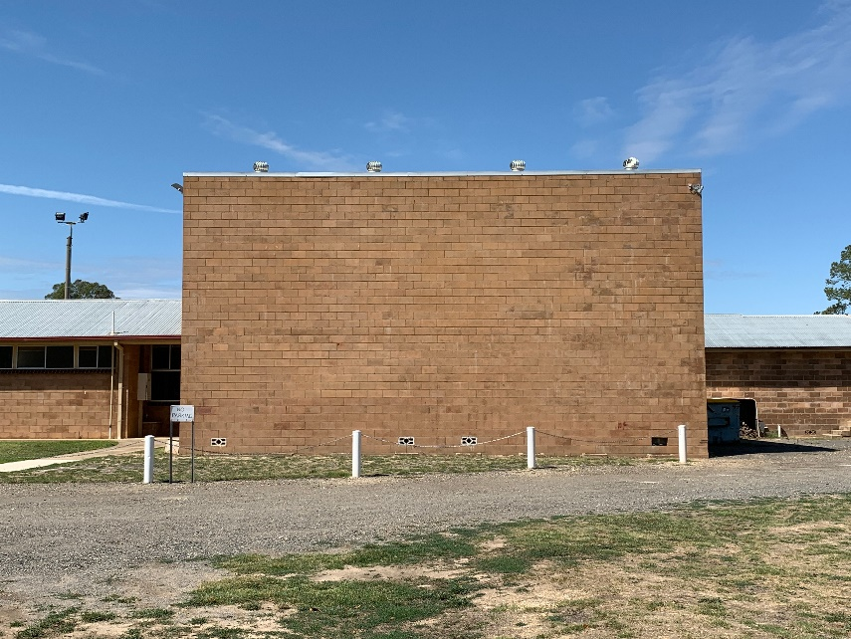

The mural site is the Chiltern Recreation and Sport Reserve along Conness Street, Chiltern (directly across from 103 Bartley Street). The wall is 13.4m wide and 7.2m high.
This mural will showcase Chiltern’s Box-ironbark forest and some of the key species it is home to.
The mural must:
- Feature Box-ironbark forest
- Feature the Regent Honeyeater and several other fauna and flora species specific to Box-ironbark forests (a list and reference images will be provided)
- Be done in a realistic style (does not need to be like a photograph, but the key species should be identifiable)
Ideally, the mural will show people interacting with nature and, if possible, a transition from day to night, so that nocturnal species can be seen.
The artwork must be treated with anti-graffiti spray after completion, as the intent is for the mural to last 5 to 10 years. Reference images of the forest/animals will be provided to the successful applicant, but this link contains good examples of the types of plants and animals that are found in a Box-ironbark forest and could appear in the mural: http://www.friendsofchiltern.org.au/index.php/biodiversity/galleries/flora-of-chiltern
Access the galleries via the Biodiversity tab.

Target audience
- Local residents of Chiltern
- Tourists/visitors to Chiltern
- Street art enthusiasts
- Local and visiting bird watchers

Budget
The budget for the commission is $25 000 and needs to be inclusive of:
- Design phase for the commission
- Provision of all materials required; including paint, application tools and anti-graffiti clear coat to protect the work after its completion
- Undertaking Indigo Shire Council’s online induction for contractors
- Any travel and accommodation costs involved
- Artist’s time to complete the installation of the final design

Compliance
The appointed artist will need to complete an Indigo Shire Council, online Contractor Induction.

Commissioning process and timeline
Action | Timeline
Call for Expression of Interest (EOI) opens | 16/03/20
EOI closes | 13/04/20
Panel assessment of EOI’s completed | 17/04/20
Artists notified if they are the preferred provider | 24/04/20
Installation of artwork undertaken along with formal unveiling, ceremony, and media | Ideally completed by June 5th (World Environment Day) for media launch, but this date is negotiable.

COVID-19 update
At this stage the mural commission will keep tracking to the proposed timeline, 50% of the agreed upon budget will be paid to the artist upon signing of the contract and the remainder will be paid upon completion of the mural. Please note that at this stage we do not envisage any delays to the assessment or contract stages but we did predict that there may be delays for the installation of the mural.

How to apply
Expressions of interest shall be forwarded to:
Natasha Cain | Natural Environment Program Officer | Hume Region
1 McKoy Street, Wodonga, Victoria 3690
M: 0447 590 471 | E: natasha.cain@delwp.vic.gov.au
Please use the subject line “Chiltern Mural EOI [your name]” for email submissions.

Expressions of interest shall include:
- A short, written response to this brief including an artist statement, outline of your proposed budget, acknowledgment that you can complete the installation within the time-line outlined and the approach you would take to the project (maximum 2 pages)
- Curriculum vitae (CV)
- Maximum of 6 images of relevant previous work with reference to dimension, location, commissioner, collaborative partners and budget
- Public liability Certificate of Currency
Please note: no designs are being called for via the Expression of Interest process.

Assessment criteria
All Expressions of Interest will be assessed against the following criteria:
- Artistic merit as evidenced by the visual material provided
- Demonstrated ability to work on comparable projects within timelines and budget
- Previous relevant experience in the public realm
- Ability to develop concepts and communicate ideas
- Demonstrated ability to create work that engages with a broad public
- Availability to work within the project timeline
- Demonstrated ability to work on permanent and durable work
- Experience with materials of relevance to the required project outcome

The Assessment panel will comprise of representatives from:
- DELWP Hume Natural Environment Program team
- DELWP Hume Communications team
- Indigo Shire Council Community Development team
- Chiltern Tourism and Development Incorporation
- Chiltern Recreation Reserve
- Murray Arts

